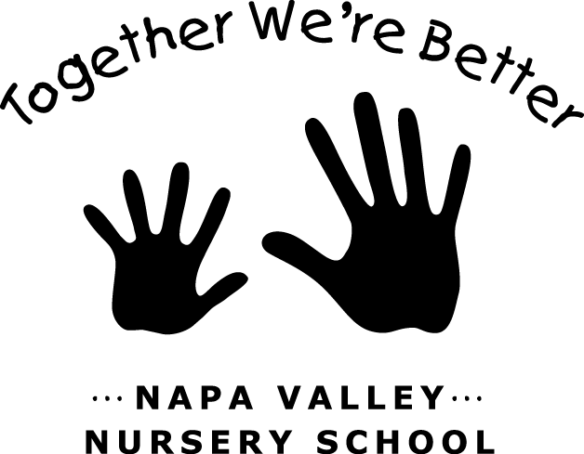

JOB: Play Yard & General Maintenance

TEAM: Maintenance

LAST UPDATED/CHANGED: April 2019

JOB DESCRIPTION:
As a Maintenance Team member, you are responsible for participating in regular maintenance duties and maintenance workdays as scheduled by the Maintenance Chair.
The Play Yard Committee is responsible basic and seasonal maintenance of NVNS’s outdoor space. The Play Yard Committee is responsible for communicating with each other, the Chair and Director to create a schedule and division of responsibilities.

JOB DUTIES:
- Perform regular and thorough completion of assigned maintenance duties.
- Participate in Maintenance Team activities and workdays as scheduled.
- Rake, blow, and remove leaves from yard as needed.
- Remove and clean up standing water from tires and other areas as needed.
- Rake sand box and gravel area. Remove debris as needed.
- Prune shoots from Safety Tree.
- Trim jasmine on inside and outside of fences.
- Cut back mint on inside and outside of fences
- Maintain garden planters: water during warm months (including summer); plant (check with Chair or Director for kid and guinea pig-safe choices); deadhead and remove dead plants as needed.

JOB REQUIREMENTS:

- Attend all Parent Meetings.
- Attend three or more Maintenance Team meetings (one at the end of summer, one after winter break and one around spring break).
- Participate in one Housekeeping Saturday per year.
- Participate in End-of-Year Cleanup.
- Participate in additional Maintenance workdays as scheduled by Maintenance Chair.
- Weekend work; may include summer work.

General Information

- The Maintenance Team is responsible for the overall maintenance of the NVNS facility: Room 1, Room 2, Shed 2 and the Play Yard.
- This job may include routine maintenance duties (weekly/monthly) and periodic work days (installing fixtures, painting, etc) as assigned/scheduled by the Maintenance Chair.

General Duties
The Maintenance Chair is responsible for the following duties throughout the school year. As a General Maintenance parent, you may be assigned any of the following regular tasks:

Classrooms
- Change light bulbs and clean light panels.
- Maintenance of smoke detectors.
- Window cleaning.

Play Yard
- Play structures & equipment maintenance.
- Drain maintenance.
- Sand/gravel maintenance.
- General yard work.

Other Duties
- Painting.
- Periodic miscellaneous projects.

