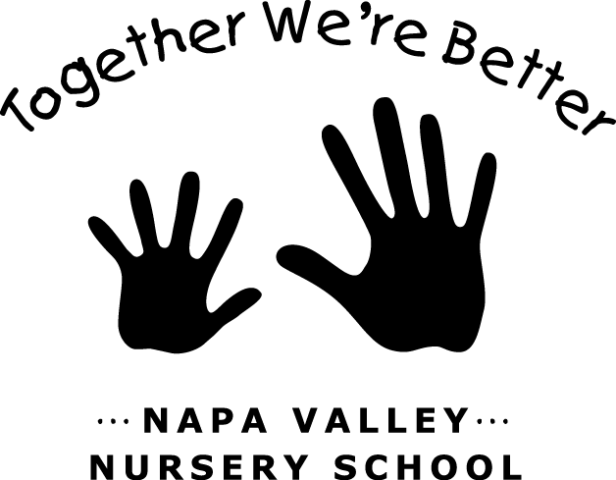

JOB: Pet Care

TEAM: Classroom Operations

LAST UPDATED/CHANGED: April 2019

JOB DESCRIPTION:
This person is responsible for the care, cleaning, and upkeep of all of the NVNS Pets.

JOB DUTIES:
- Purchase all pet food, bedding, supplies, etc within the budget found in
the current year’s budget proposal.
- Maintain pet cages and aquarium in working order.
- Regularly clean cages/aquarium, keeping them clean and sanitary.
- Arrange care for pets over holiday breaks (yourself or other NVNS family)

JOB REQUIREMENTS:
- Attend all Parent Meetings.
- Participate in one Housekeeping Saturday per year.
- Participate in End-of-Year Cleanup.
- Must be available to regularly clean pet cages, aquarium, etc.
- Periodic out-of-pocket spending that is reimbursed by school check when
receipts are submitted to the Treasurer.
- Periodic errands to restock pet food, supplies, etc.

General Information

Pet care supplies and food are stored in Room 2 in the cabinet below the pet cage(s)/aquarium(s). You are responsible for inventory and for purchasing food and supplies on a regular basis. Items that are purchased on a regular basis are as follows:

Wilson’s Feed (we have a charge account):

- Mazuri Guinea Pig Pellets 25lb bag
- Cage Liner (recycled bedding)
- Timothy Hay
- Vitamin C Water Drops
- Fish Food (Gold fish flakes)

Guinea Pig cage requires cleaning on a weekly basis (or more frequently if veggie consumption is high and cage is soiled). Cage cleaning takes approximately 20 min and can involve the assistance of children. A convenient time to do this is at pick up.

To clean cage:

- Place guinea pig(s) in safe area (herb bed, basket).
- Remove bed, toys, dishes, etc. from cage and set aside.
- Bring trash can near cage.
- Gently lift bedding and wet newspaper to dispose in trash bag.
- Spray bottom of cage with spray bottle mixture of vinegar and water
(50% each) and clean using paper towels.
- Dry cage.
- Reline cage using multiple layers of old newspaper folded to fit perimeter
of cage bottom.
- Cover newspaper with 1-2inches of fresh bedding.
- Spray food dishes with vinegar and water mixture (50% each) and wipe
with paper towel.
- Waterer can be cleaned with water and rock salt if algae appears.
- Refill food and water - return to cage.
- Place guinea pig back in cage and give them a few fresh veggies treats.
- Clean up counter and floor around cage area.
- Guinea pig water and drip bowl should be checked with each visit to
school. Refresh as needed.

- Keep pet food/supply storage cabinets clean and organized; vacuum as
needed.

- Fish tank requires cleaning approximately once a month. Arrange with Director for first “hands-on” demo of tank and filter cleaning. This will include the removal of approximately 2/3 of the tank water. Keep a large container of water stored under the Room 2 sink. This water will become de-chlorinated and become room temp for future cleanings.

- Periodically, NVNS will host other pets; polliwogs, chickens, butterflies, etc. Discuss special pet needs with Director as they arrive.

