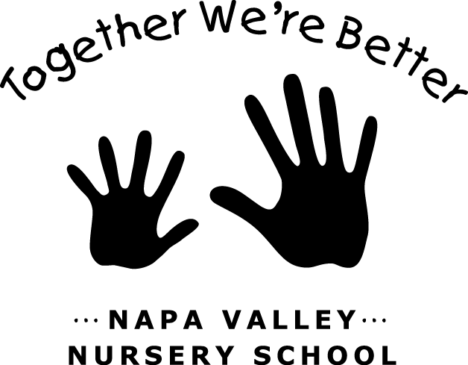

JOB: Publicity and Events

LAST UPDATED/CHANGED: March 2016

TEAM: Vice President

JOB DESCRIPTION:

The publicity and events job involves working at the Napa Moms Club Preschool Fair, coordinating the holiday float for the Napa Holiday Parade, and working at Parent Information Night. This job can be shared with up to three families.

JOB DUTIES:
- Responsible for the Preschool Fair, Holiday Float, and Parent Information Night events.
- Sign the school up for appropriate events. Generally, the Holiday Parade is the Saturday after Thanksgiving, the Preschool Fair is in early January, and Parent Information Night is in February.
- Coordinate volunteers to help staff the Preschool Fair and construct the holiday float.
- Communicate details about the participating in the Holiday Parade with the school.
- Stay under the yearly budget for the float (refer to current year’s budget). We have many items, including lights, in shed 2. You may borrow items from families or solicit donations! Be creative!
- Set up table/booth at preschool fair. Have a sign-up sheet to collect info for prospective NVNS families.
- Check to see that there are magnets, fliers, or other advertising materials to distribute.
- Assist the director with any duties leading up to parent information night.
- Assist in any additional celebrations or events that may vary from year to year.

JOB REQUIREMENTS:
- Attend all Parent Meetings.
- Participate in one Housekeeping Saturday per year.
- Participate in End of Year Clean up.
- Good communication skills.
- Ability to work collaboratively with others.

GENERAL INFORMATION:

As the Publicity/Events coordinator you will be in charge of outreach events in the community where prospective families learn more about our parent corporative school.

Multiple families will share this job. Work may be divided up in a way that is mutually agreed upon by those involved.

