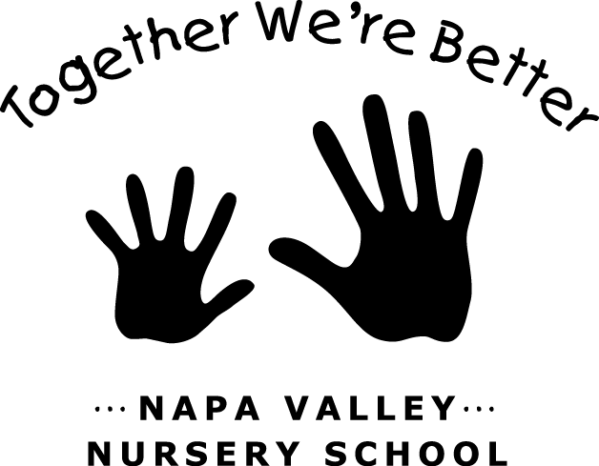

JOB: General Maintenance Safety Monitor

TEAM: Maintenance

LAST UPDATED/CHANGED: January 2017

JOB DESCRIPTION:
This is a General Maintenance Safety Monitor. As a Maintenance Team member, you are responsible for participating in regular maintenance duties and maintenance workdays as scheduled by the Maintenance Chair about three to four per year.
As the General Maintenance Safety Monitor you are point person for all the safety equipment with the support of the Maintenance Chair and Director.

JOB DUTIES:
- Perform regular and thorough completion of assigned maintenance duties.
- Participate in Maintenance Team activities and workdays as scheduled.
- Responsible for refiling and yearly check of fire extinguishers prior to the opening of the school year
- Carbon Monoxide and Fire alarm battery replacement and monthly tests
- Check and replace water filter in Room 1 (under the sink)
- Monthly padlock checks on all locked items (sheds, bikes, perimeter)
- Check and refill First Aid box in Room 1
- Check and refill large First Aid/Disaster Supplies Bin in Shed 2 (make sure clear access is available)
- Confirm return of all checked out School Key (monthly and end of year)

JOB REQUIREMENTS:
- Attend all Parent Meetings.
- Attend three or more Maintenance Team meetings (one at the end of summer, one after winter break and one around spring break).
- Participate in one Housekeeping Saturday per year.
- Participate in End of Year Clean up.
- Participate in additional Maintenance workdays as scheduled by Maintenance Chair.
- Weekend work; may include summer work.

General Information

- The Maintenance Team is responsible for the overall maintenance of the NVNS facility: Room 1, Room 2, Shed 2 and the Play Yard.
- This job may include routine maintenance duties (weekly/monthly) and periodic work days (installing fixtures, painting, etc) as assigned/scheduled by the Maintenance Chair.

General Duties

The Maintenance Chair is responsible for the following duties throughout the school year. As a General Maintenance parent you may be assigned any of the following regular tasks.

Classrooms
- Change light bulbs and clean light panels.
- Maintenance of smoke detectors.
- Window Cleaning.

Play Yard
- Play Structures & Equipment Maintenance.
- Drain Maintenance.
- Sand/Gravel Maintenance.
- General Yard Work.

Other Duties
- Painting.
- Periodic Projects.

