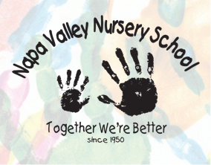

Napa Valley Nursery School 641 Randolph St. Napa ,Ca 94559 707-224-3319